Rebecca Vessal

Professor Jefferson

IDM/Section 01

27 September 2011

Decorate Cake Day Greeting Card

ABSTRACT:

National Decorate Cake Day greeting card provides a fun, interactive experience for the user to decorate their own cakes. The user is presented with the ingredients of a cake on a wooden table and a button with the label, Decorate Your Cake. Once the user clicks on the button, he or she is directed to the main scene where the user can decorate a cake. Multiple buttons on the right side of the screen will change the color of the cake. Cake decorating items can be dragged onto the cake itself. Once the user is done with their cake, they click on the done button, located on the bottom right of the screen. Main scene transitions to the credits scene where the user can click on the decorate another cake button to replay the greeting card.

DESIGN:

INTRODUCTION SCENE

First the user is presented with scene of an egg rolling onto the stage. Then bowl rushes in for the action from the right side, and sugar rains from above. Flour drops from above. A milk carton slides from the left. Finally a golden button rotates onto the scene and has the label, Decorate Your Cake.

MAIN SCENE

The cake is the center of the screen. Multiple buttons on the right side of the screen enable the user to choose the color for the cake. There are a strawberry and an apple below the cake color changing buttons. A chocolate fondue machine constantly generates chocolate fondue. Once the user clicks on the piper, he or she needs to hold down the mouse and drag to put icing on the cake. There will be a bowl of sugar sparkling for making crystal sugar. Once the user is done with creating their cake, he or she needs to click on the done button located on the bottom right of the screen. A flash will occur before moving onto to the credits scene.

CREDITS SCENE

A photo of their cake pops up. The credits will appear above the photo. The Decorate Another Cake button will appear below the picture of the user’s decorated cake. The button will redirect the user to the introduction again.

All of these scenes create a sense of the user creating a cake.

VISUAL DIAGRAM OF NESTED MOVIECLIPS: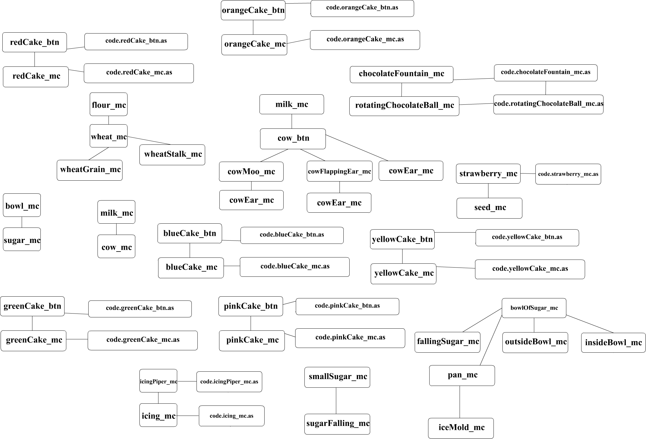

TECHINICAL ISSUES (3):

I had trouble with adding and removing different color cake movieclips from the stage. I used an array to store the specific color cake movieclip that the user selected by clicking on the specific color cake button and remove the previous cake movieclip from array. For some reason, the array length would change from 1 to 0 before any movieclip was removed. I solved this problem by changing the checking pop() of the cake array to simply an index of 0 of the cake array.

Another issue I had dealt with was cleaning up the dynamic icing movieclips. I simply created an array to store all of the dynamic icing movieclips and then removed all of them once the user clicked on the Decorate Another Cake button, which brings the user back to the title screen.

The cow movieclip and sugar falling movieclips plays twice in the title screen. I fixed this problem by getting rid of the second instances in the main timeline.

HIDDEN/EXTRA FEATURES:

If the user hover over the cow on the milk carton, it will start flapping its ear. The icing piper dynamically creates icing if the user click and drag on the piper. If you hover over the chocolate ball, it will rotate, change size, and change its position slightly.